Ladies.. You’re invited!

Who: Cranberry Girl Scouts, grades 6-12
What: Earn your “Female Empowerment” IP badge
When: Saturday, February 17, 2018 from 1:00-3:00
Where: Cranberry Municipal Center, Brush Creek Room
Why: Spend the day learning about women’s issues and empowering one another! We will also be completing a service project by donating lightly used clothing
Fee: $5.00 fee which includes badge and a snack; bring used clothes to donate

Checks made payable to GSWPA Cranberry
Mail forms/payment to Sarah Donaldson @ 148 Hampshire Drive, Cranberry Twp. PA, 16066

Name of Girl Scout(s) attending:
Total amount included:
Adult email address:
Troop #:

For more information, contact Sarah Donaldson at (724) 766-5723 or sarah.donaldson148@gmail.com.

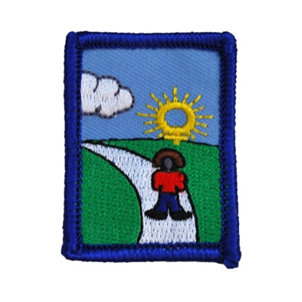
Attention Cranberry Area Girl Scouts! Earn your Female Empowerment IP Badge!

Hello! My name is Sarah Donaldson. For my senior project, I have decided to hold a badge work day so that local Girl Scouts (grades 6-12) can earn their Female Empowerment IP Badge. To earn this badge, we will be discussing topics such as the issue of sexual harassment and the lack of female representation in many careers. The two-hour badge day will consist of speakers and workshops. We will also be completing a service project which will be a clothing drive to donate to victims of domestic abuse. Girls that plan on attending should bring used clothes that they are willing to donate.
The cost of the event is $5.00, which covers the cost of the Female Empowerment IP Badge plus a snack and a drink. The event will be from 1:00-3:00 in the Brush Creek Room at the Cranberry Municipal Center on Saturday, February 17, 2018. To register, please mail (or drop off) the registration form/payment to my house before February 1, 2018. The address is 148 Hampshire Dr., Cranberry Twp. PA, 16066. There are only 25 spots, so register now! If you have any questions, don’t hesitate to contact me by email at sarah.donaldson148@gmail.com or by phone at (724) 766-5723.

